DS-3WAP6230-EI
Wi-Fi 6 3000M Ceiling Access Point

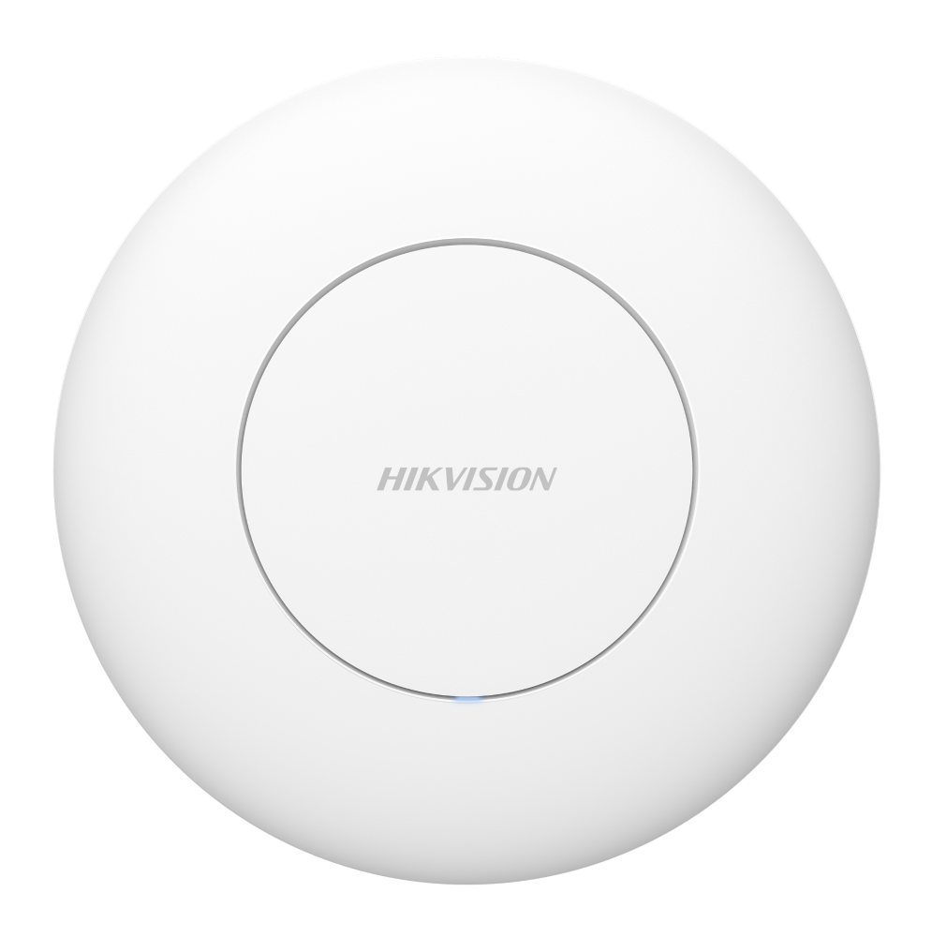

DS-3WAP6230-EI is an indoor 802.11ax AP product with dual-frequency four-flow design , which meets the wireless coverage requirements of small, medium and micro enterprises.

- 1 × Gigabit PoE in port,1 × Gigabit RJ45 port
- Wi-Fi 6 Dual Band 3000 Mbps
- Auto RF Optimization
- Wide Signal Coverage
- Reliable Wi-Fi Connection
- Outstanding Wall Penetration

- Specification
General
Net Weight | 0.4 kg (0.88 lb)
Gross Weight | 0.64 kg (1.41 lb)
Installation Mode | Ceiling Mounting
Working Temperature | 0°C to 40°C (32°F to 104°F)
Working Humidity | 10% to 90% (no condensation)
Storage Temperature | -40°C to 70°C (-40°F to 158°F)
Storage Humidity | 5% to 95% (no condensation)
Product Dimensions (W × H × D) | Ø220 mm × 49.7 mm (excluding bracket）
Packing List | 3000 M Access Point × 1, Screw Pack × 1, Installation bracket × 1, Quick Start Guide × 1, Regulatory Compliance and Safety Information × 1
Power Supply Method | DC power supply: 12 V, 2 A;  PoE power supply: IEEE 802.3at;
Max. Power Consumption | 18 W
Wireless Parameter
Wireless Speed | Max: 2976 Mbps;  2.4G: 574 Mbps;  5G: 2402 Mbps;
Wireless Standard | Wi-Fi 6
Working Frequency Band | Radio 1: 5G (11a/n/ac/ax);  Radio 2: 2.4G (11b/g/n/ax);
Bandwidth | 2.4G: Auto/20/40 MHz;  5G: Auto/20/40/80/160 MHz;
Recommended Coverage Range | Recommended Coverage Range: 140 m², the radius in an open environment is 25 meters.  Note: The signal coverage range is greatly affected by the environment. For example, walls, glass doors, and other obstacles will affect the signal coverage. The above - mentioned values are for reference only.
Max. Number of Connected Clients | 256
Recommended Number of Connected Clients | 110
Spatial Streams | 2.4G: 2 × 2, MU-MIMO  5G: 2 × 2, MU-MIMO
Transmitting Power | 2.4G: Combined power: 28 dBm;  5G: Combined power: 30 dBm;  Note: The actual transmission power varies according to regulations in different countries and regions;
Wireless Security | WPA2-PSK, WPA-WPA2-PSK, WPA3-PSK, WPA2-WPA3-PSK
Antenna Type | Built-in omnidirectional antennas
Antenna Gain | 2.4 GHz: 3.5 dBi  5 GHz: 4.5 dBi
Hardware Specifications
Ports | 1 × Gigabit PoE in port, 1 × Gigabit RJ45 port
RESET | 1 × Reset hole
Software Specifications
Max. Number of Wireless SSIDs | 8
Internet Access Mode | DHCP,Static
VLAN ID Range | 1~4000
Max. Number of VLANs | 8
Software Features
Operation Mode | AP mode (default);  Routing mode;
Wireless Management | Support wireless configuration;  Support RF configuration;  Support Health Mode;  Support guest SSID;  Support wireless roaming;  Support wireless optimization;  Support wireless SSID speed limit;  Support wireless RF speed limit;  Support wireless intelligent speed limit;  Support wireless terminal speed limit;  Support weak signal access control;  Support weak signal to kick offline;  Support roaming sensitivity adjustment;  Support wireless access control;  Support wireless terminal association;
Interface | Support uplink port VLAN;  Support MAC address modification;  Support LAN configuration;  Support Port VLAN;
IP Services | Support DHCP Client;  Supports DHCP Server;  Support LLDP;  Support SADP;
Service and Support | Support NAT Traversal;  Support Audit Log;  Support Fault Diagnosis;  Support Fault Alarm;  Support One-Click Fault Collection;  Support Network Diagnostic Tools;  Support SSH;  Support Cloud Service Diagnosis;  Support Local Upgrade;  Support Online Upgrade;  Support Cloud Service;  Support App Management;
Approval
EMC | CE-EMC (EN 55032:2015/A1:2020 EN 55035:2017/A11:2020 EN IEC 61000-3-2:2019/A2:2024 EN 61000-3-3:2013/A2:2021 EN 50130-4:2011/A1:2014)
Safety | CB (IEC 62368-1: 2018), CE-LVD (EN IEC 62368-1: 2020+ A11: 2020)
Chemistry | CE-RoHS (2011/65/EU), WEEE (2012/19/EU), Reach (Regulation (EC) No.1907/2006)
Radio | EN 300 328, EN 300 440, EN 301 893, EN 301 489-1, EN 301 489-3, EN 301 489-17, EN 61000-3-3: 2013+ A1:2019+A2: 2021, EN IEC 61000-3-2: 2019+A1: 2021+A2: 2024, EN IEC 62311: 2020

- Available Model
DS-3WAP6230-EI

- Dimension
